G52CPP Coursework 4 Documentation sheet

Your name/id: Jialu ZHANG 2125383

Coursework name: Explore Jungle

Summary: <summarise what your program does. E.g racing game, word processor, pacman, bomberman, etc and list any key features you want to highlight which are not covered below>

<INSERT ONE OR MORE SCREENSHOTS HERE TO ILLUSTRATE YOUR GAME>

**Mandatory (compulsory) requirements: tick them and add a few words of comment if it helps you/us to know what to demo/mark**

1. **Appearance looks OK and appropriate**

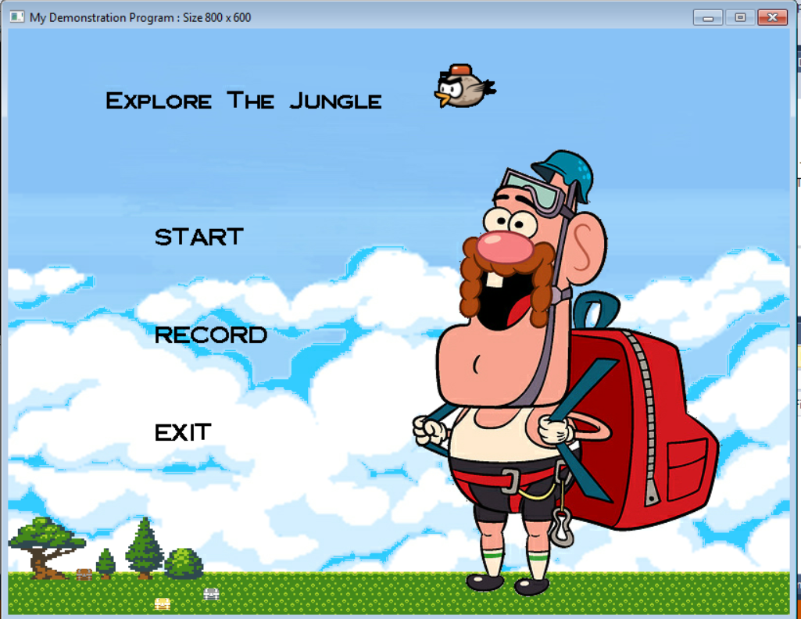

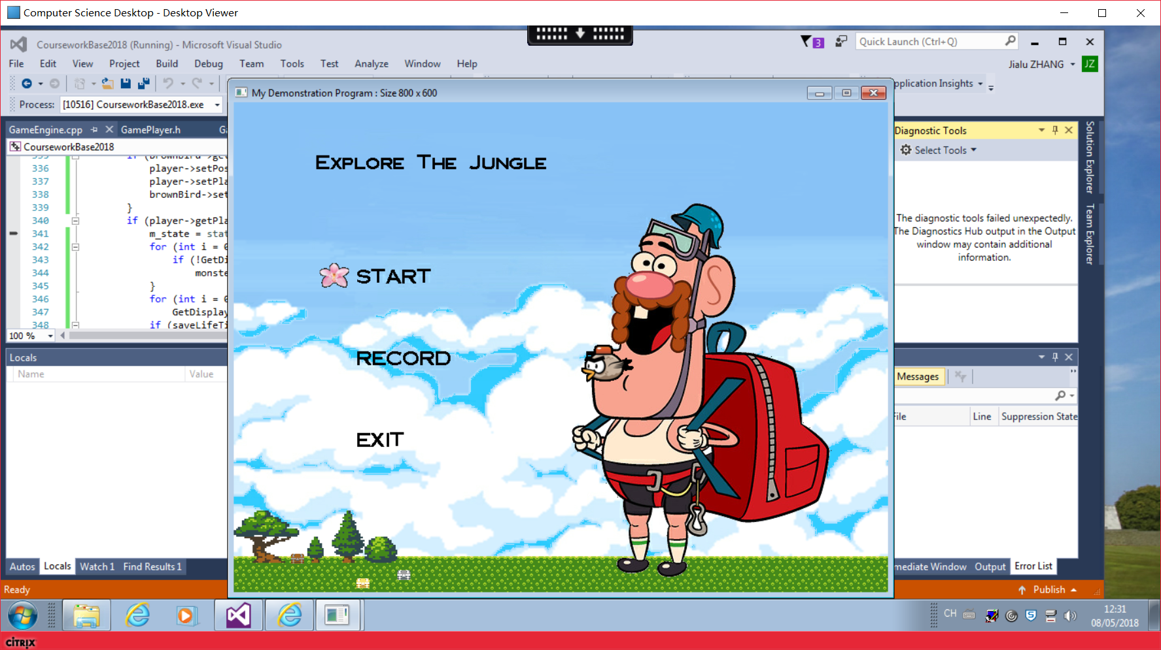

1. **Provide multiple states/stages**

**Initial, main ,failed, successful,…**

1. **Use the tile manager appropriately – changing at least one tile**

**Heart & key**

1. **Improve your user-controlled moving object**

**player**

1. **Provide multiple different automated moving objects**

**All objects except flowers and player**

1. **Provide interaction between moving objects, or a moving object and background**

**collision**

1. **Display meaningful changing text on the screen**

**Time, life, key**

1. **Program works well and looks good**

**No crash**

**Optional requirements – which did you do and what did you do to complete these? Add a few keywords to remind you what to demo.**

**A. Load some data**

**B. Advanced data loading**

**C. Data saving**

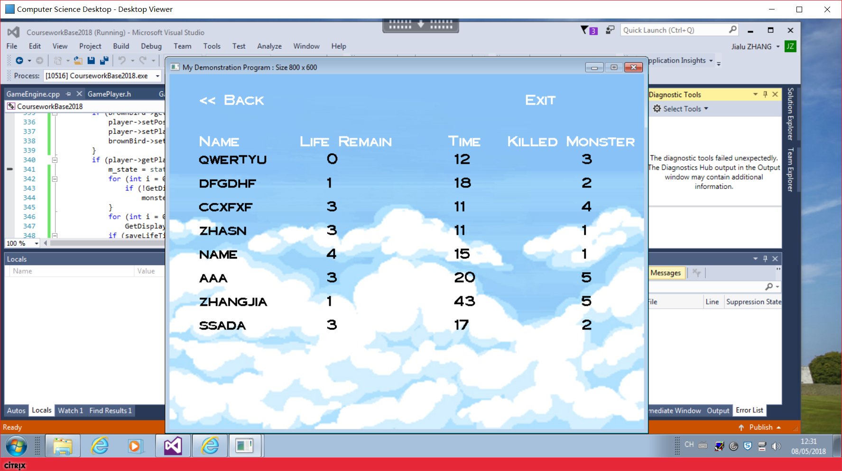

**D. Save/load non-trivial state**

**E. Advanced (e.g. animated/scrolling) background**

**F. Animated appearance of user controlled object and/or automated objects**

**G. Displayable object images**

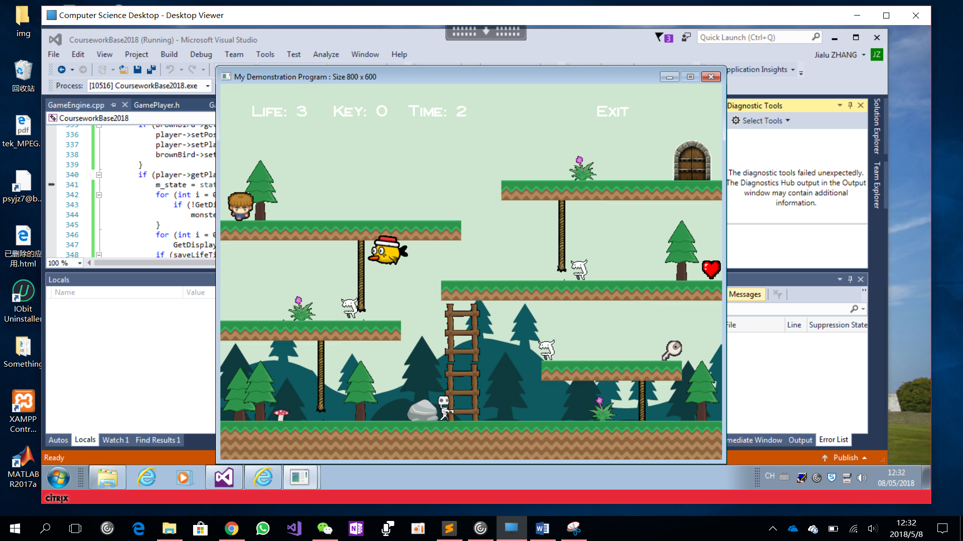

**H. Creating new displayable objects during the game**

**bullet**

**I. Allow user to enter text which appears on the graphical display**

**Record the name after wining.**

**J. Display text aligned with moving objects**

**Name of the character – Alen**

**(shown after Mouse click in main stage)**

**K. Complex intelligence on an automated moving object**

**Bird flies to player by the shortest path.**

**L. Impressive intelligence on an automated moving object**

**M. More complex tile manager interaction**

**Key & heart**

**N. Implement a hierarchy of moving object classes**

**DisplayableObject -> Monsters->Birds**

**DisplayableObject ->Flowers->Bullet**

**O. Non-trivial pixel-perfect collision detection**

**P. More complex collision detection**

**Bird & player**

**Bullet & monsters**

**Q. Really complex collision detection**

**R. Polymorphic state structure**

**S. Implement full pause facility**

**Pause Stage**

**T. Sellable quality**

**U. Another advanced feature**

**V. A second advanced feature**